**FARMER MARKET APP**

**USER GUIDE**

**LIST OF CONTENTS**

DESCRIPTION 2

MAIN PAGE 2

View of the page: 3

Search: 4

Sort: 4

Refresh: 6

Choose: 6

MARKET PAGE 7

View of the page: 7

Get to other pages: 8

Comments: 8

Read: 8

Add: 9

Change: 11

Delete: 13

Search for markets nearby: 14

EXIT 16

# DESCRIPTION

«Farmer market» application enlists US farmer markets.

It gives opportunity to:

* search for markets by name, city, state or zip;
* order results by name from A to Z or Z to A, by city, state, ranks and votes;
* read information about the market;
* read and add comments and ranks;
* change and delete comments and ranks if you log in using password;
* search for markets situated in the radius of N miles from a chosen market.

«Farmer market» application consists of the Main page and Market page. Main page is devoted to all the markets in the application, whereas Market page, to one market in particular.

# MAIN PAGE

Main page enlists all the markets in the application.

Here you can:

* read brief information about markets;
* search for markets by name, city, state or zip;
* order results by name from A to Z or Z to A, by city, state, ranks and votes;
* choose a particular market and go to its page;
* exit the application.

## View of the page:

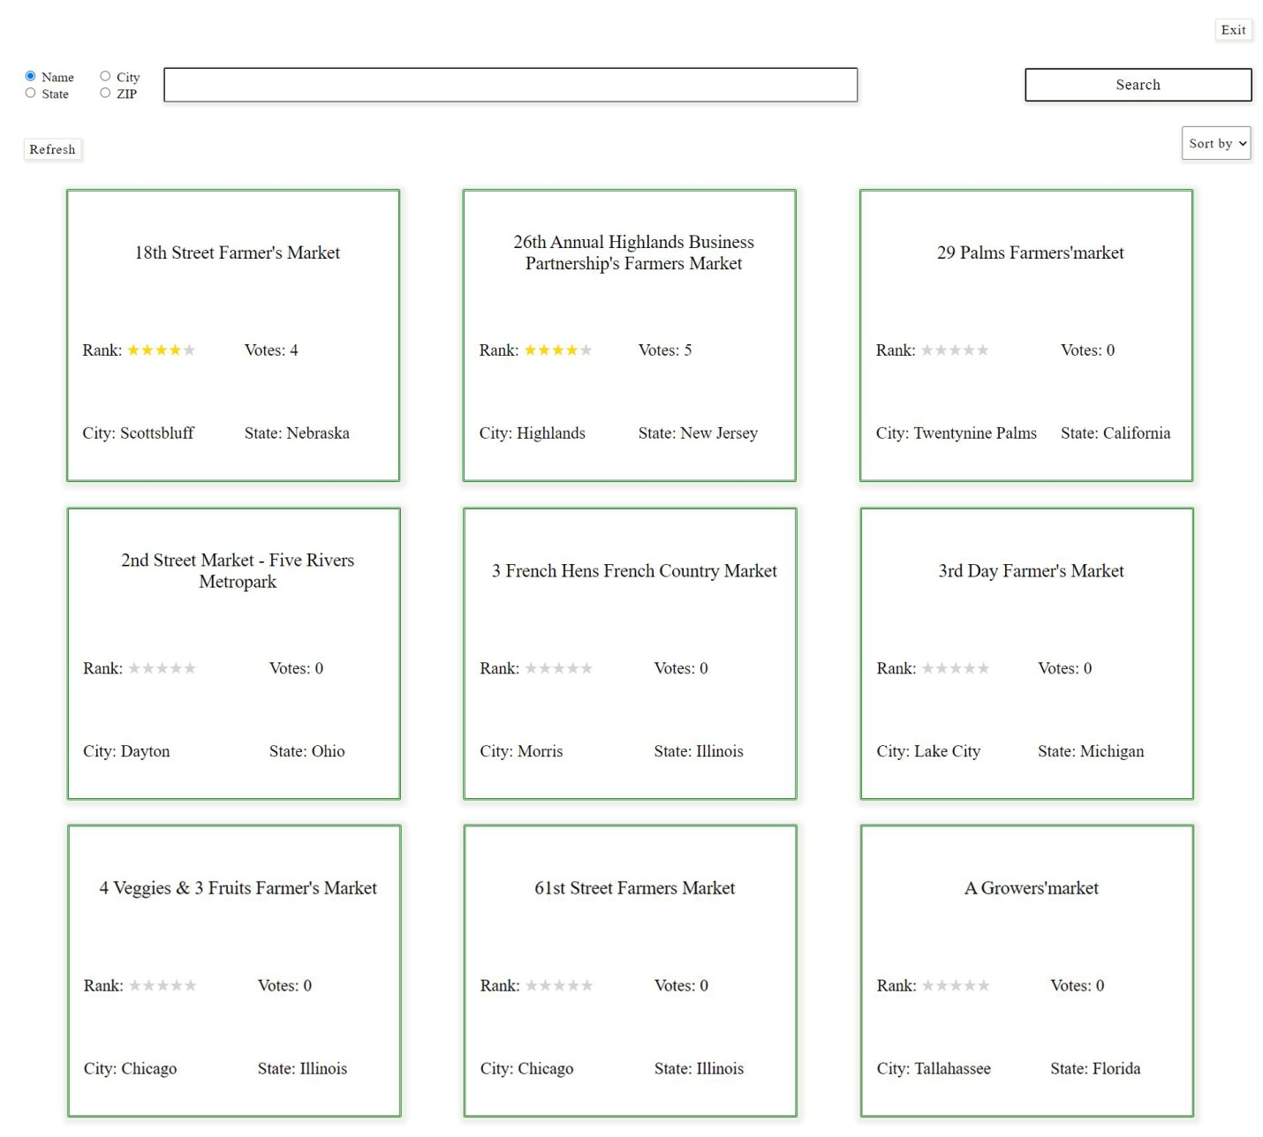

Picture 1. Main page

## Search:

Search for markets by name, city, state or zip.

Default searching criteria: market name.

1. Choose your criteria in the upper left corner of the page:

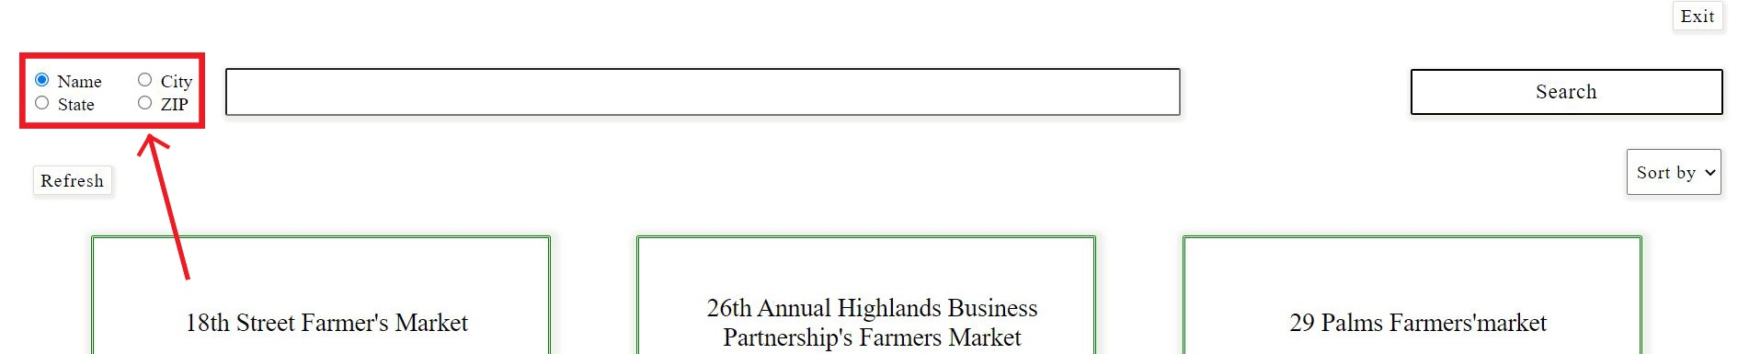

Picture 2. Searching for market. Choosing searching criteria

1. Start entering a name and then press «Search» button:

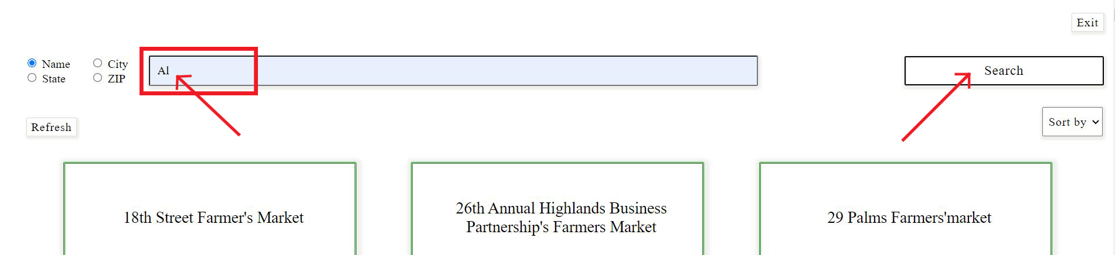

Picture 3. Searching for market. Entry and «Search» button

## Sort:

Order results by name from A to Z or Z to A, by city, state, ranks and votes.

Default sorting: market names from A to Z.

1. Click «Sort by» drop-down list:

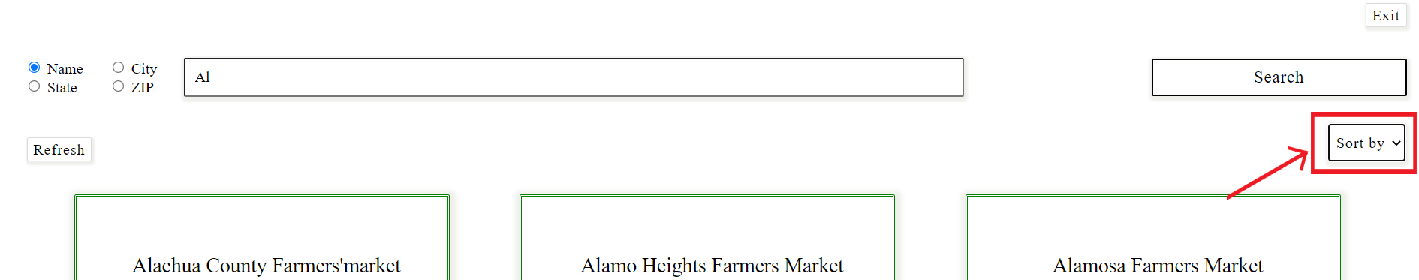

Picture 4. «Sort by» drop-down list

1. Choose sorting criteria:

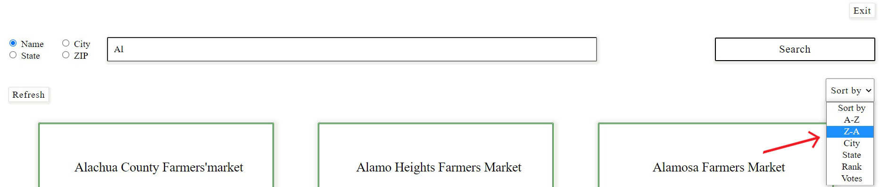

Picture 5. «Sort by» drop-down list. Choosing criteria

Example «Searching by state»

1. Choose criteria, enter the name, press «Search» button:

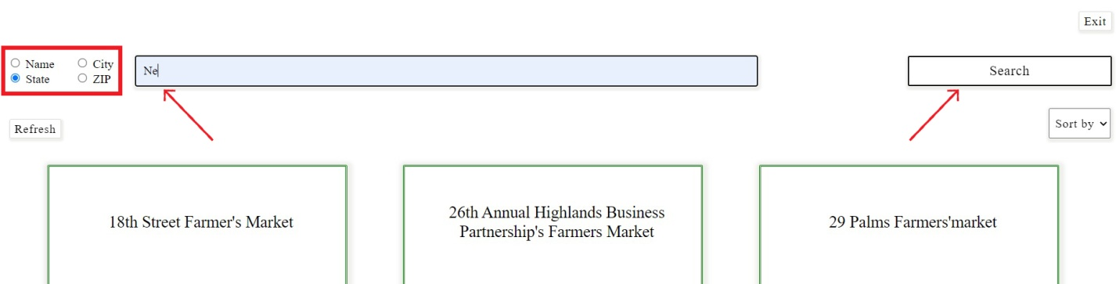

Picture 6. Searching by state. Searching criteria, entry and «Search» button

1. Click «Sort by», choose sorting criteria (optional):

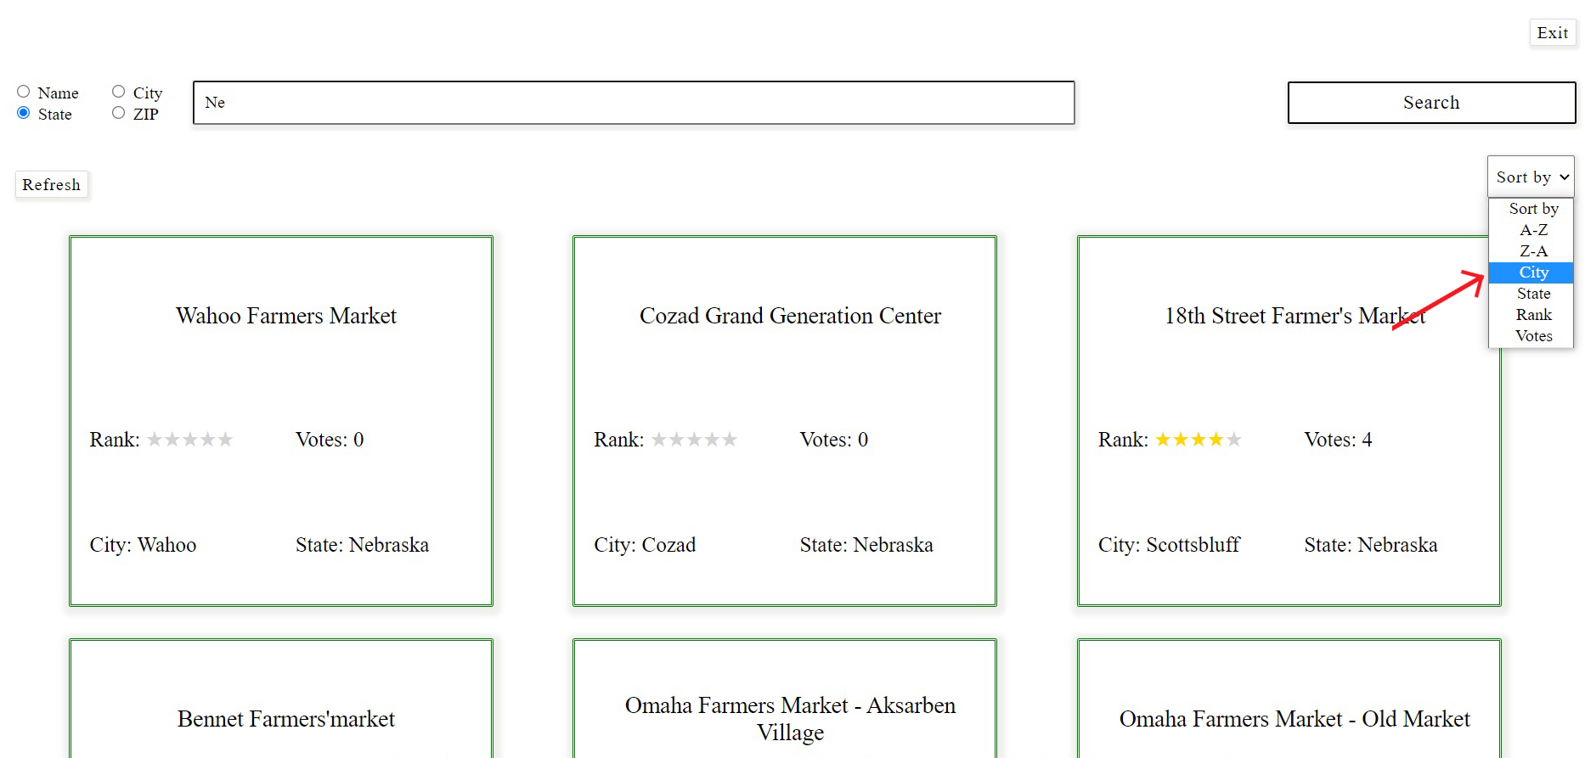

Picture 7. Searching by state. Sorting

If you are searching by state and sorting by state, results will be given in alphabetic order of states.

1. Explore the results:

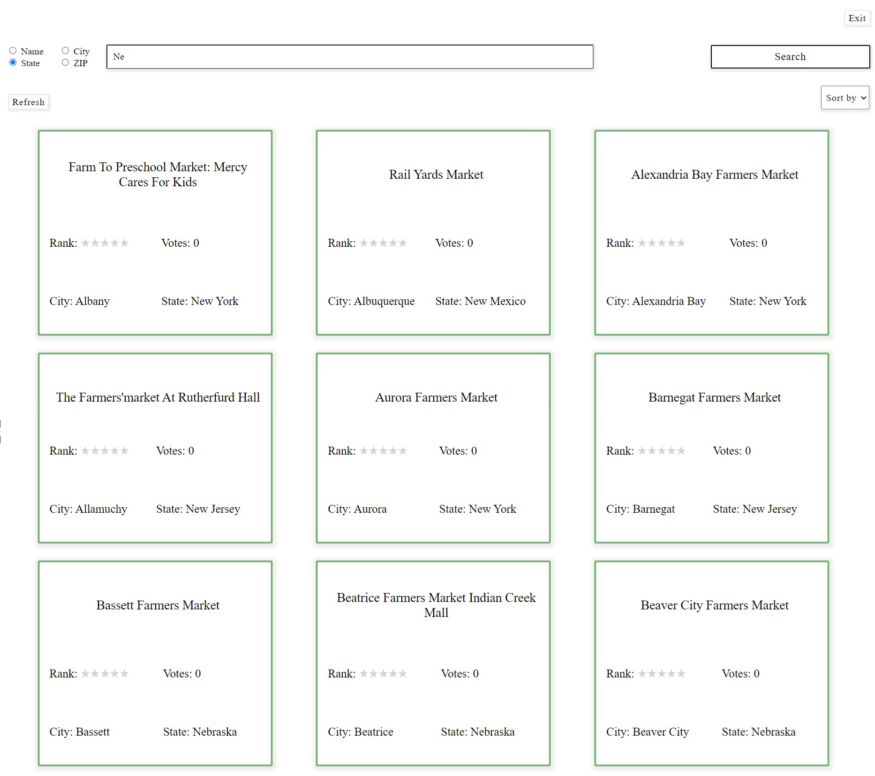

Picture 8. Searching by state, sorting by city. Results

## Refresh:

To get all the markets back to the Main page, press «Refresh» label:

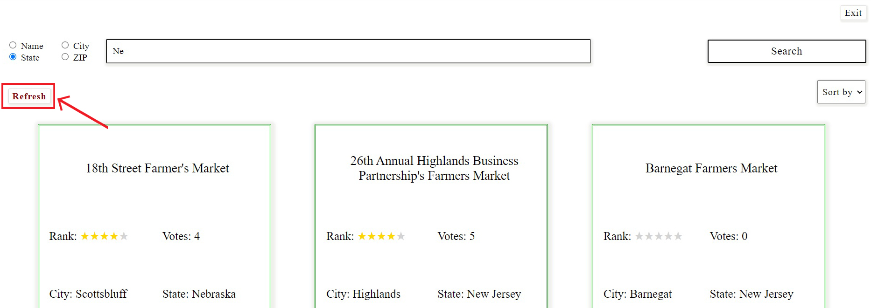

Picture 9. «Refresh» label

## Choose:

To choose a market, get your cursor over the needed one. The card will become bigger and text will change its color. Click the card and get to the page with full information about the market (see Market page).

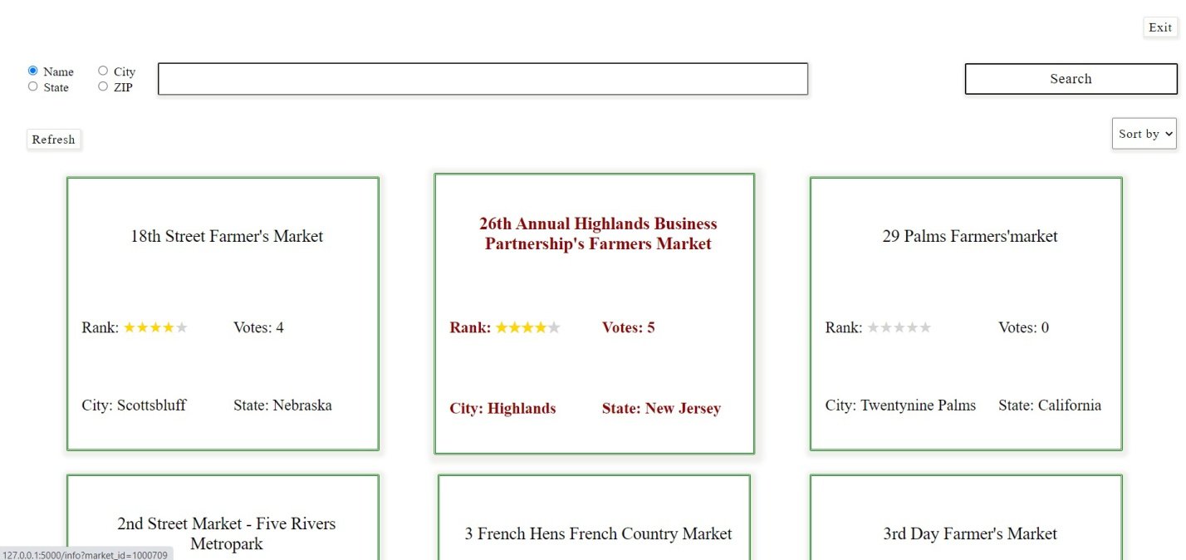

Picture 10. Choosing a market

# MARKET PAGE

Market page provides full information about one particular market.

Here you can:

* read full information about the market;
* get to the pages of next and previous markets or go back to the Main page;
* read and add comments and ranks;
* change and delete comments and ranks, if you log in using password;
* search for markets situated in the radius of N miles from this one;
* exit the application.

## View of the page:

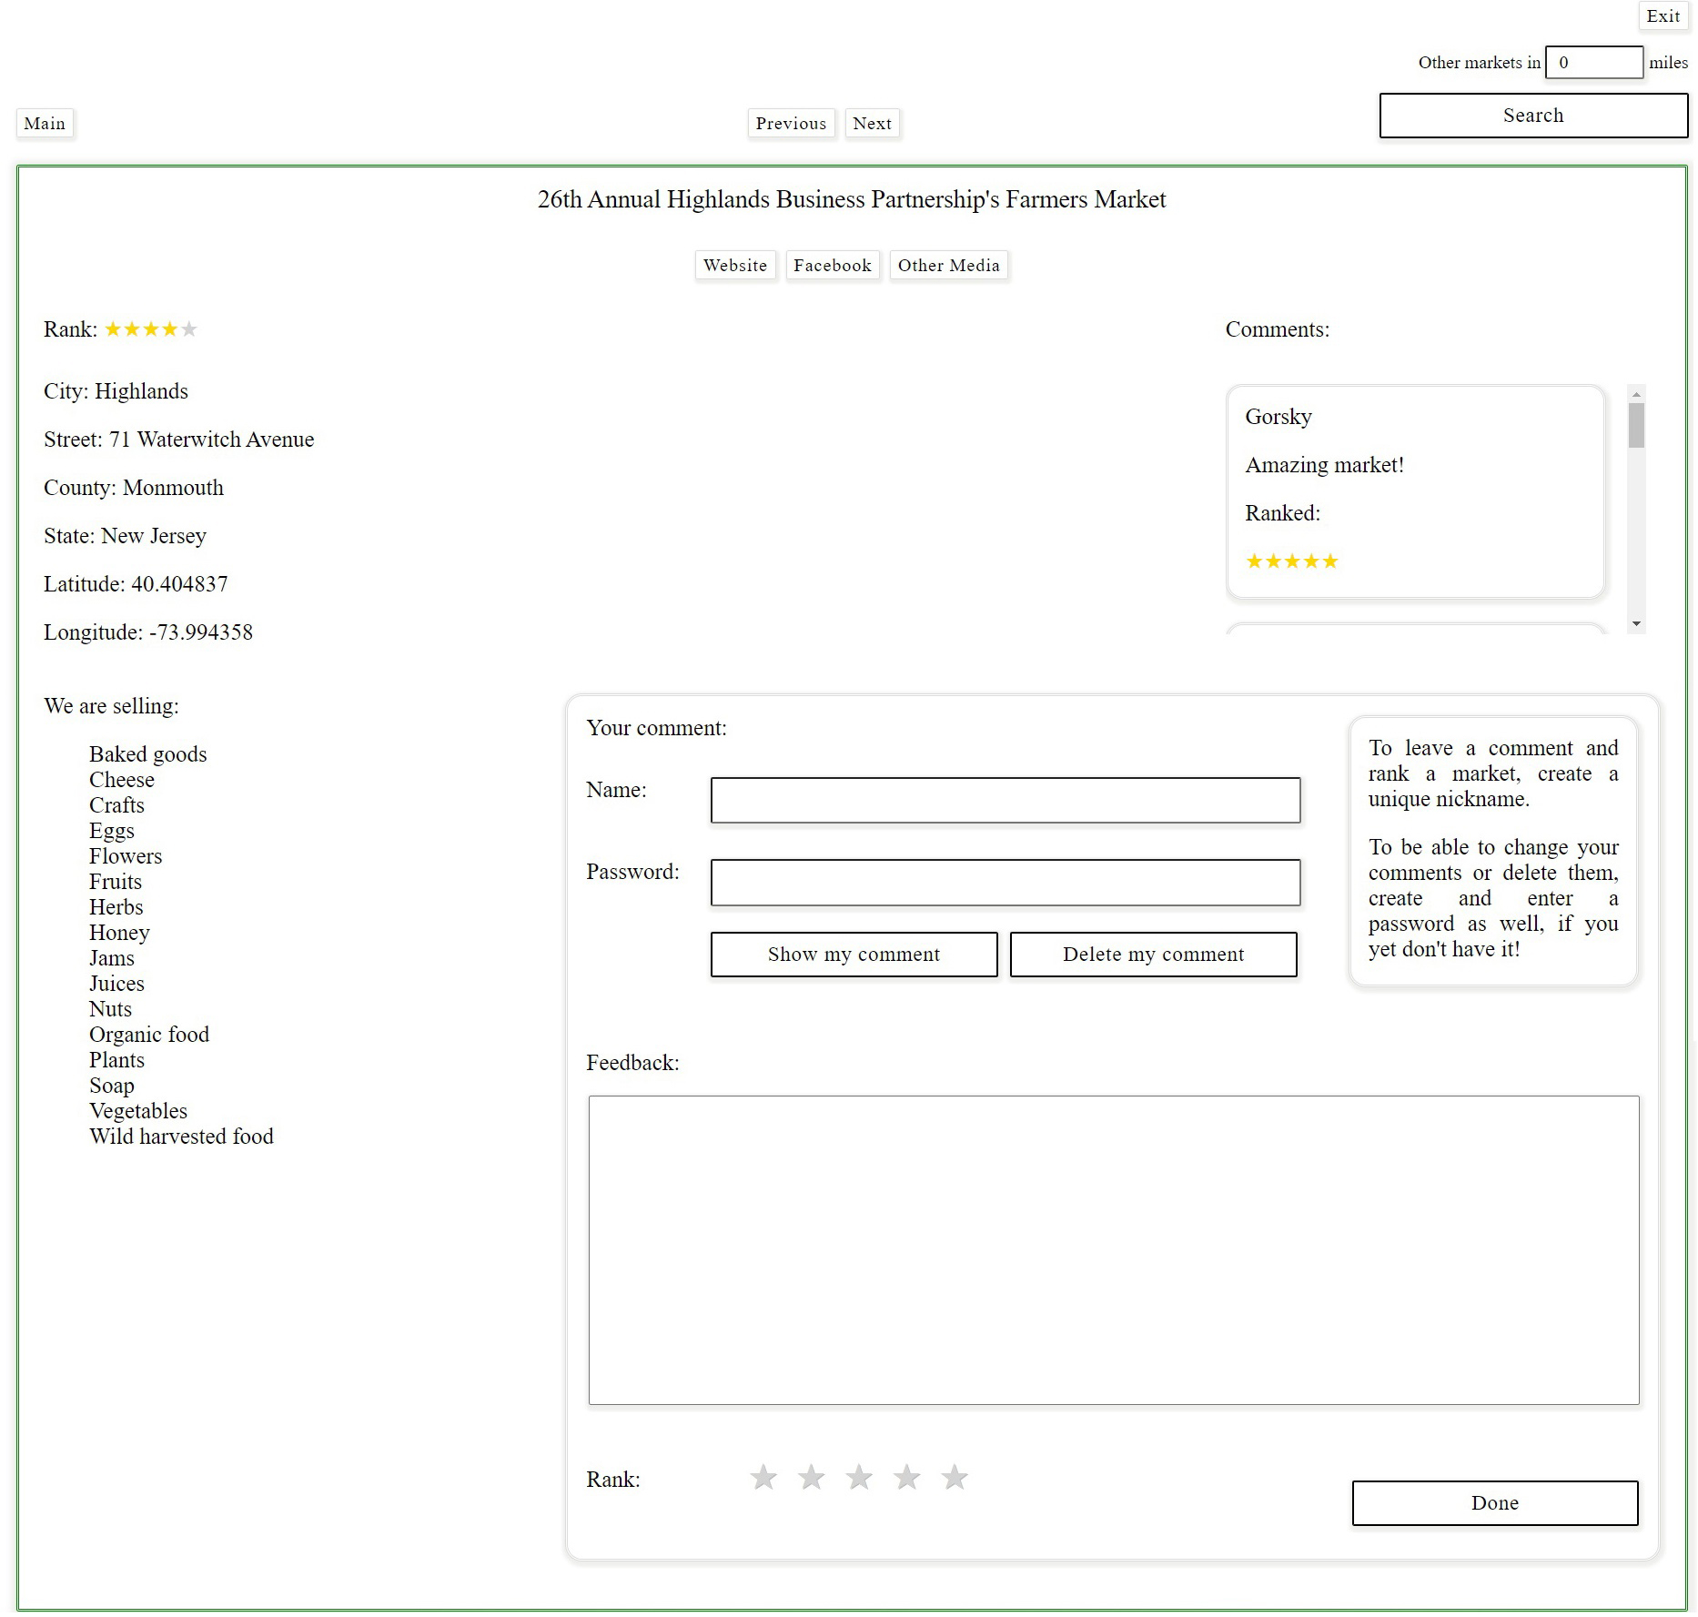

Picture 11. Market page

## Get to other pages:

Use the menu in the upper side of the application to get to other pages:

* Click «Main» to go back to the Main page;
* Click «Previous» to go to the page of the previous market in the list sorted by name from A to Z;
* Click «Next» to go to the page of the next market in the list sorted by name from A to Z;

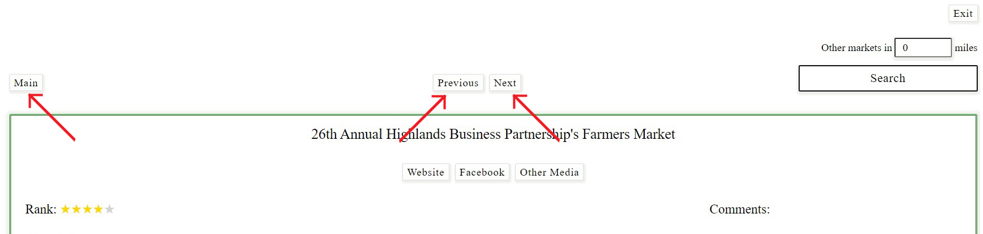

Picture 12. «Main», «Previous» and «Next» labels

## 

## Comments:

This application allows reading and adding comments and ranks and also changing and deleting them.

### Read:

Read comments of users and find out, how they are ranking the market. Scroll this section to see all the reviews.

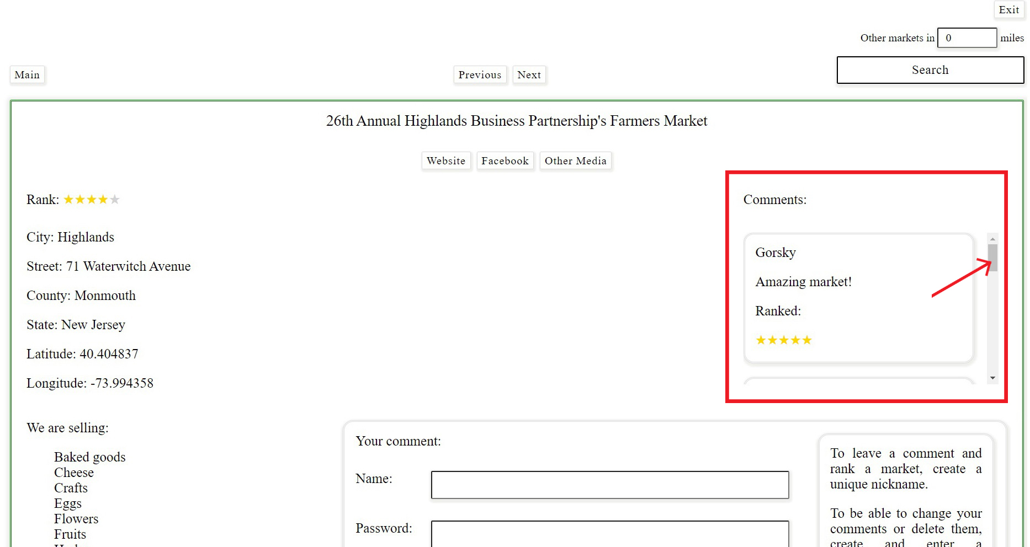

Picture 13. Comments of users

### Add:

Add your own comment and rank.

Use comment-form to leave a review and log in, if you are a new user:

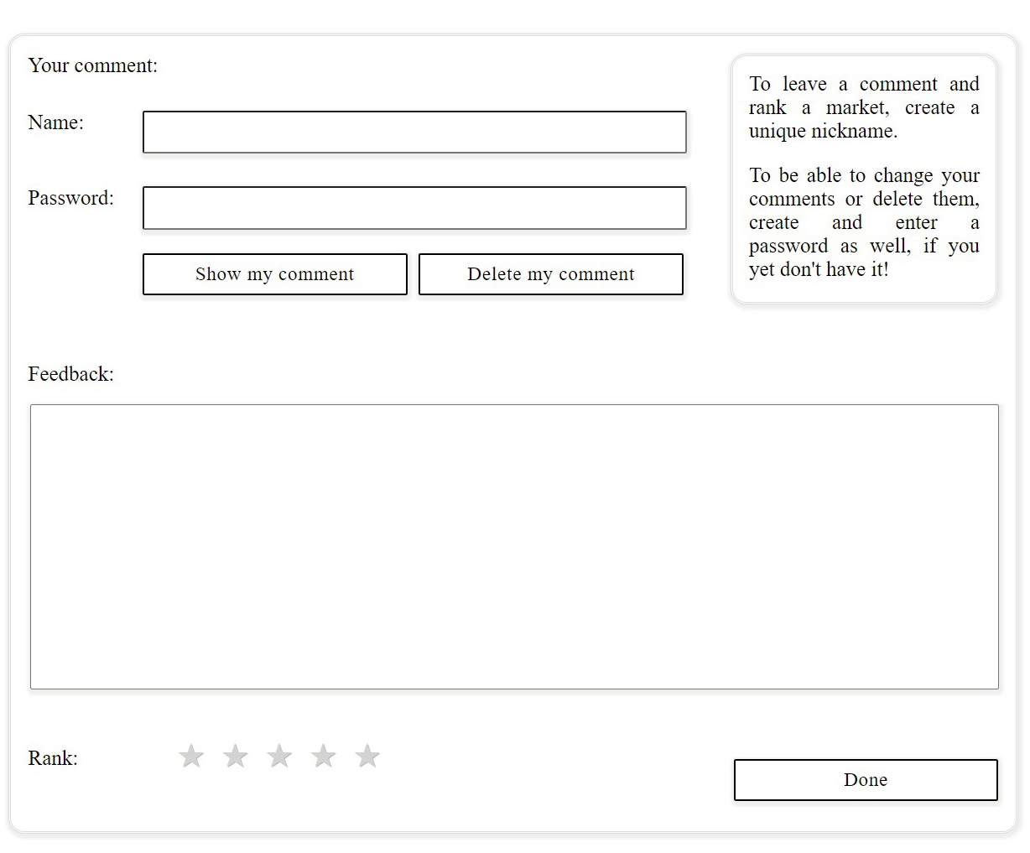

Picture 14. Comment-form

1. Enter your name and password (optional) to leave a comment. Your name should be unique. Password will give you an opportunity to change and delete your comment and rank.

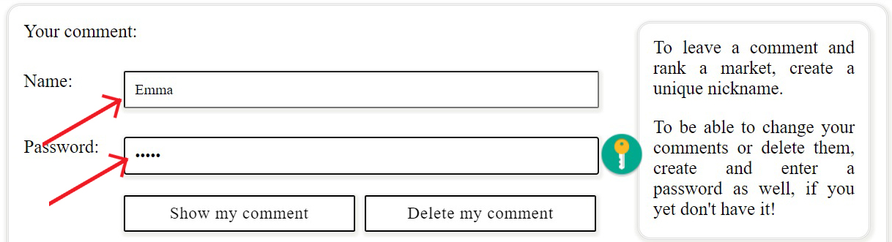

Picture 15. Adding a comment. Entering name and password

|  |  |
| --- | --- |
| 1. Write your comment: | Picture 16. Adding a comment. Writing a comment |
| 1. Rank the market: | Picture 17. Adding a comment. Ranking a market |
| 1. Press «Done» button: | Picture 18. Adding a comment. «Done» button |

1. Your comment will appear in the «Comments» section:

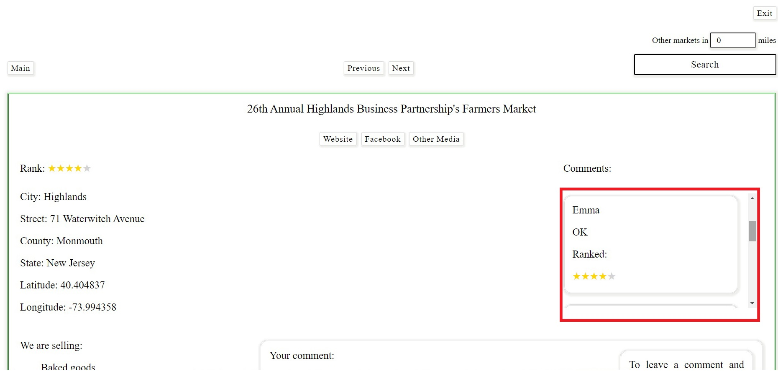

Picture 19. Adding a comment. New comment

### Change:

If you logged in using password, you can change your comment and rank.

1. Enter your name and password (mandatory):



Picture 20. Changing a comment. Entering name and password

1. Click «Show my comment» button, if you want your comment and rank to appear in the comment-form (optional):

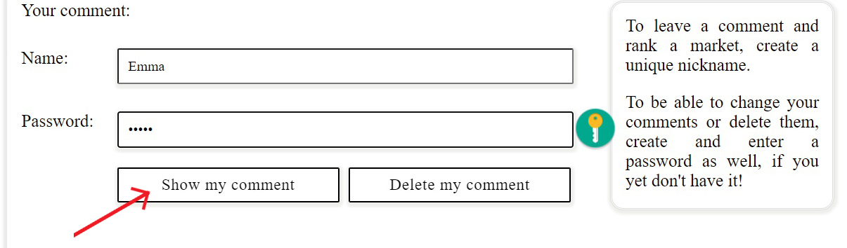

Picture 21. Changing a comment. «Show my comment» button

Your comment and rank will appear in the comment-form. Note that «Password» entry is empty again:

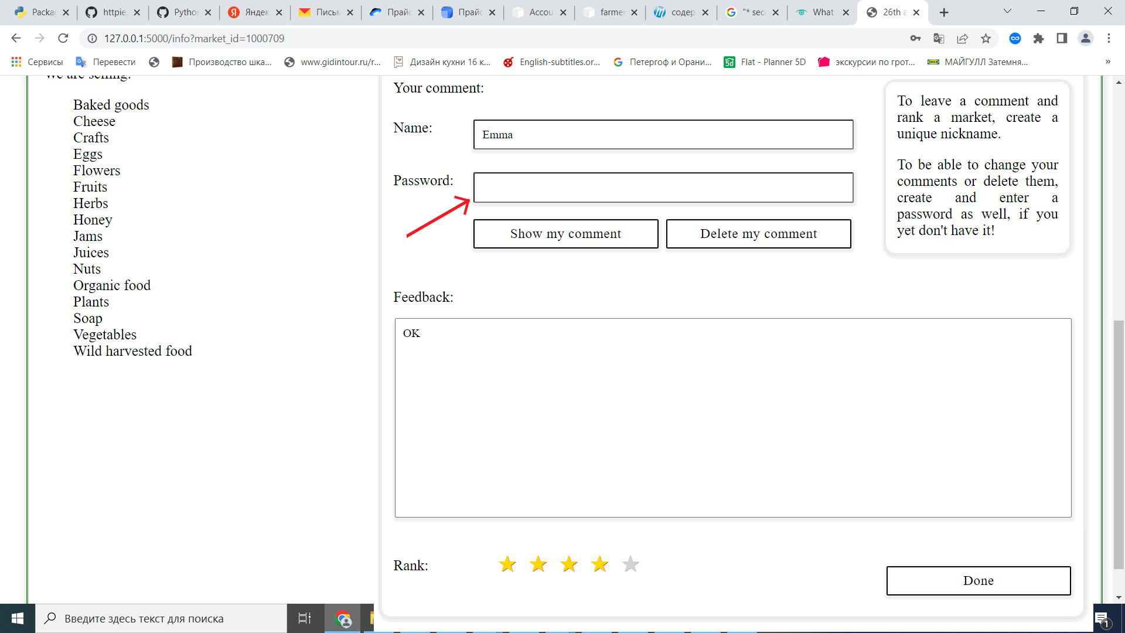

Picture 22. Changing a comment. Shown comment

1. Change your comment and/or rank:

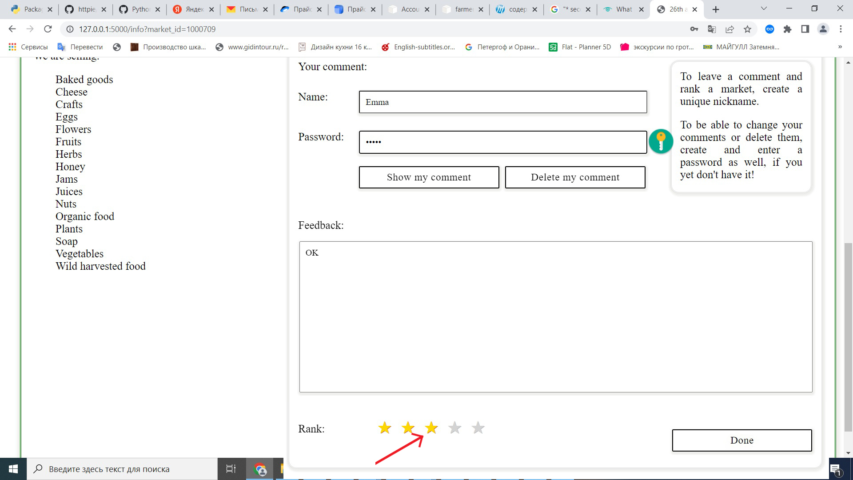

Picture 23. Changing a rank

1. If you clicked «Show my comment» button, enter your password again:

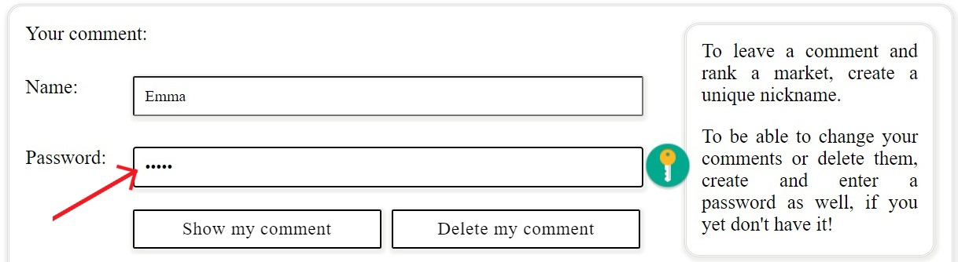

Picture 24. Changing a comment. Entering password

1. Press «Done» button:

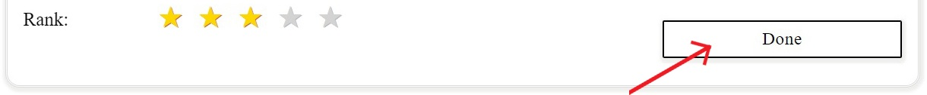

Picture 25. Changing a comment. «Done» button

1. Look at the Comments section:

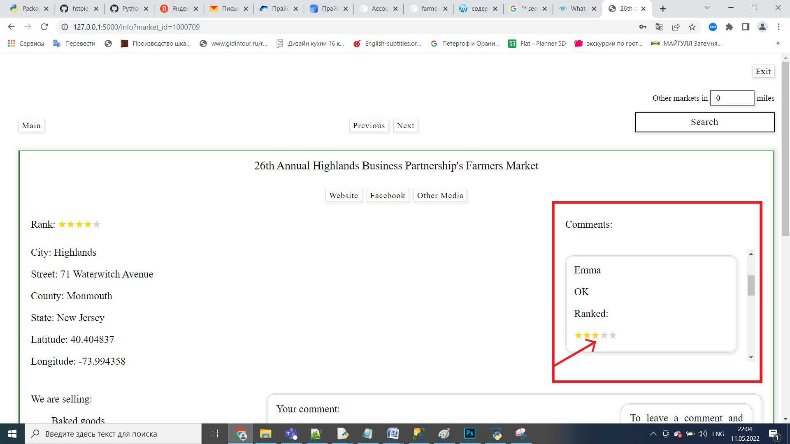

Picture 26. Changing a comment. Changed comment

### Delete:

If you logged in using password, you can delete your comment and rank.

1. Enter your name and password (mandatory):



Picture 27. Deleting a comment. Entering name and password

1. Click «Show my comment» button, if you want your comment and rank to appear in the comment-form (optional):



Picture 28. Deleting a comment. «Show my comment» button

Your comment and rank will appear in the comment-form. Note that «Password» entry is empty again:

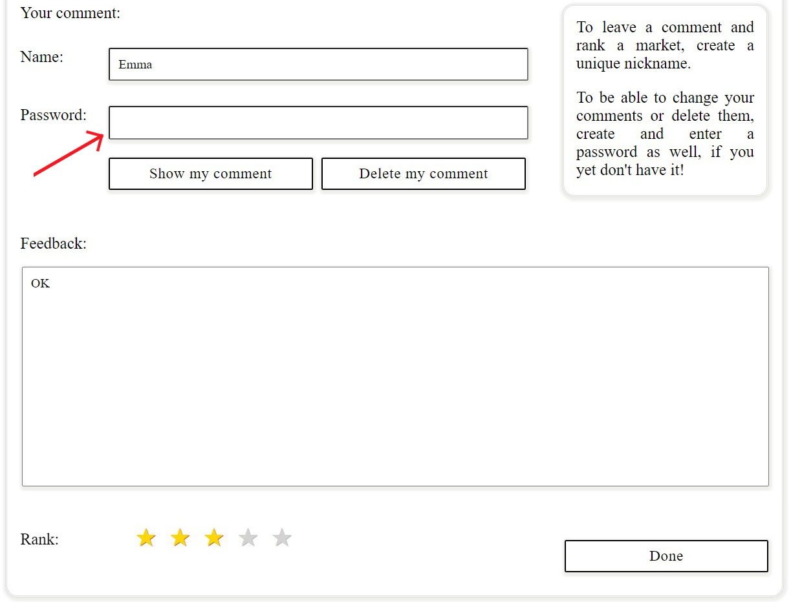

Picture 29. Deleting a comment. Shown comment

1. If you clicked «Show my comment» button, enter your password again:



Picture 30. Deleting a comment. Entering password

1. Click «Delete my comment» button:

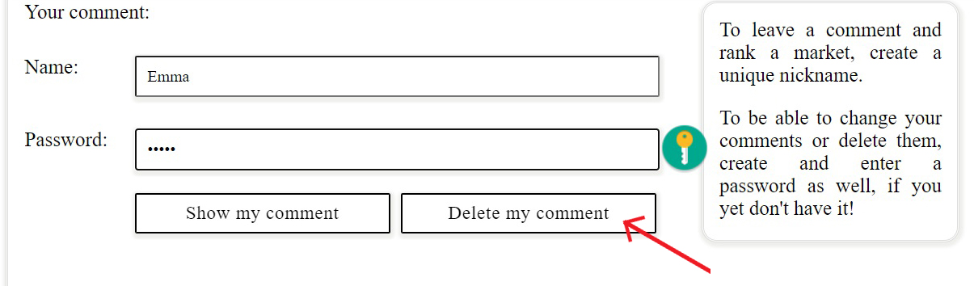

Picture 31. Deleting a comment. «Delete my comment» button

Your comment will disappear from the Comments section.

## 

## Search for markets nearby:

Find markets within the radius of N miles.

1. Enter the distance and press «Search» button:

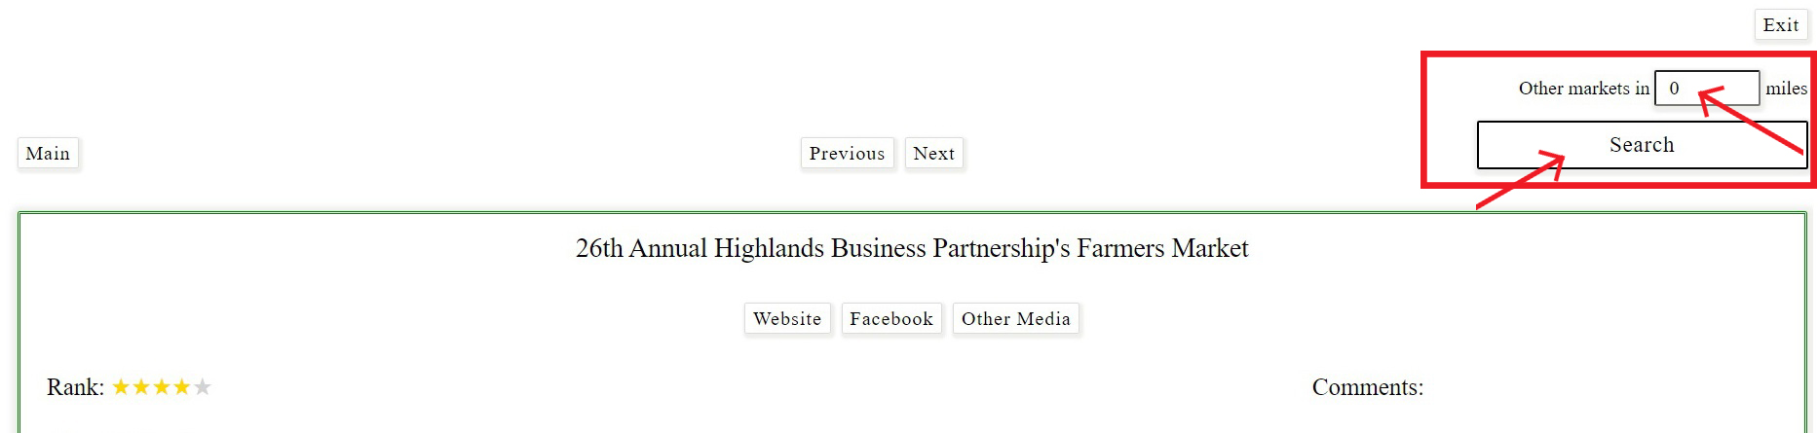

Picture 32. Searching for markets nearby. Entry and «Search» button

1. If application finds any market within the given radius, it will open up a new section with the results:

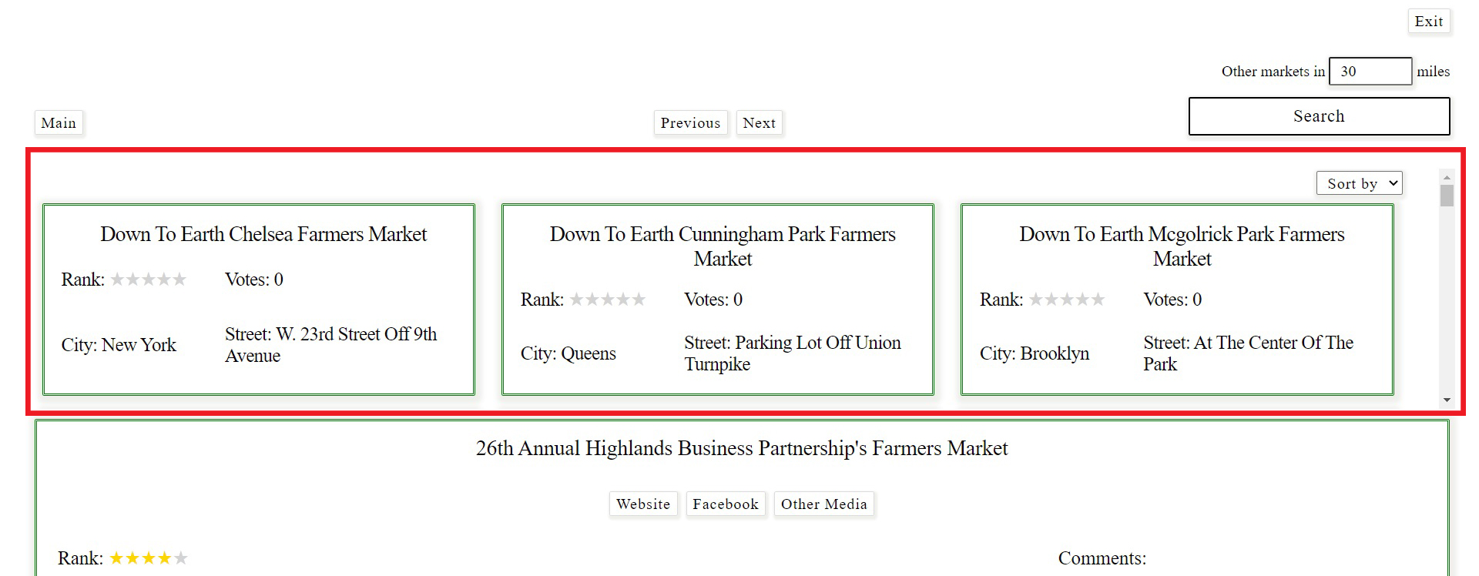

Picture 33. Searching for markets nearby. Results

1. Order results by name from A to Z or Z to A, by distance (closest ones first), city, ranks and votes (optional).

Default sorting: market names from A to Z.

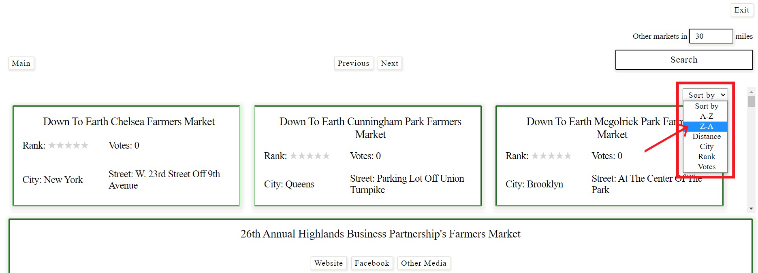

Picture 34. Searching for markets nearby. Sorting

1. Scroll this section to see all the markets within the radius:

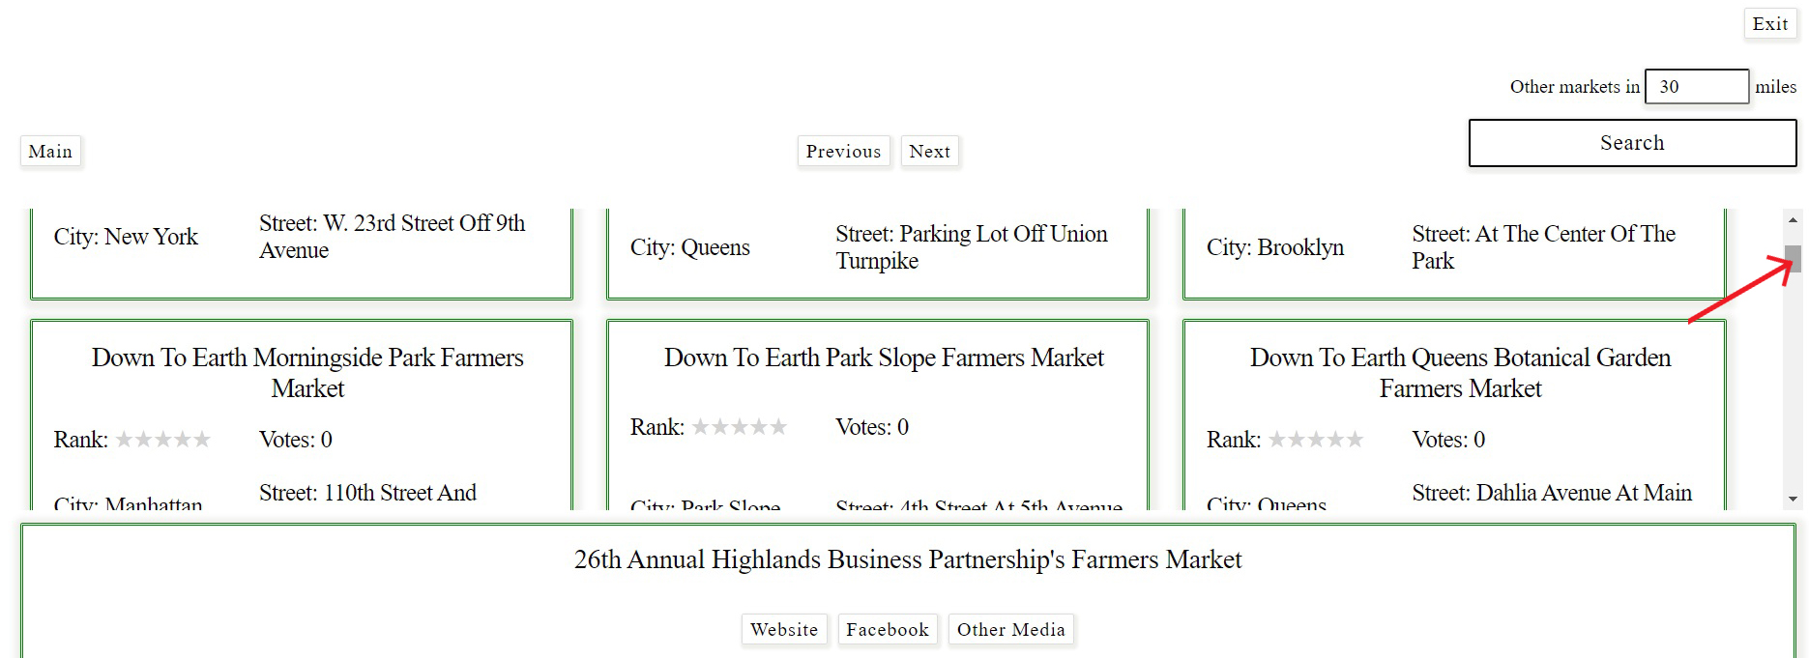

Picture 35. Searching for markets nearby. Scrolling

# EXIT

To exit the application, press «Exit» label in the upper right corner of any page.

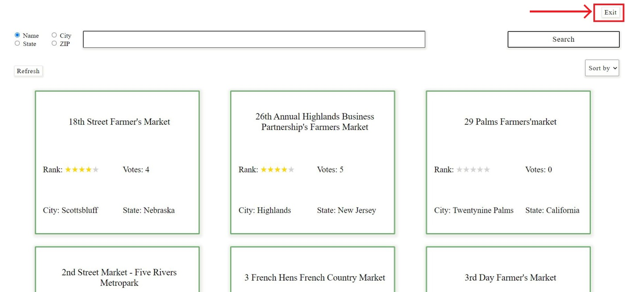

Picture 36. «Exit» label